
Calculation Policy

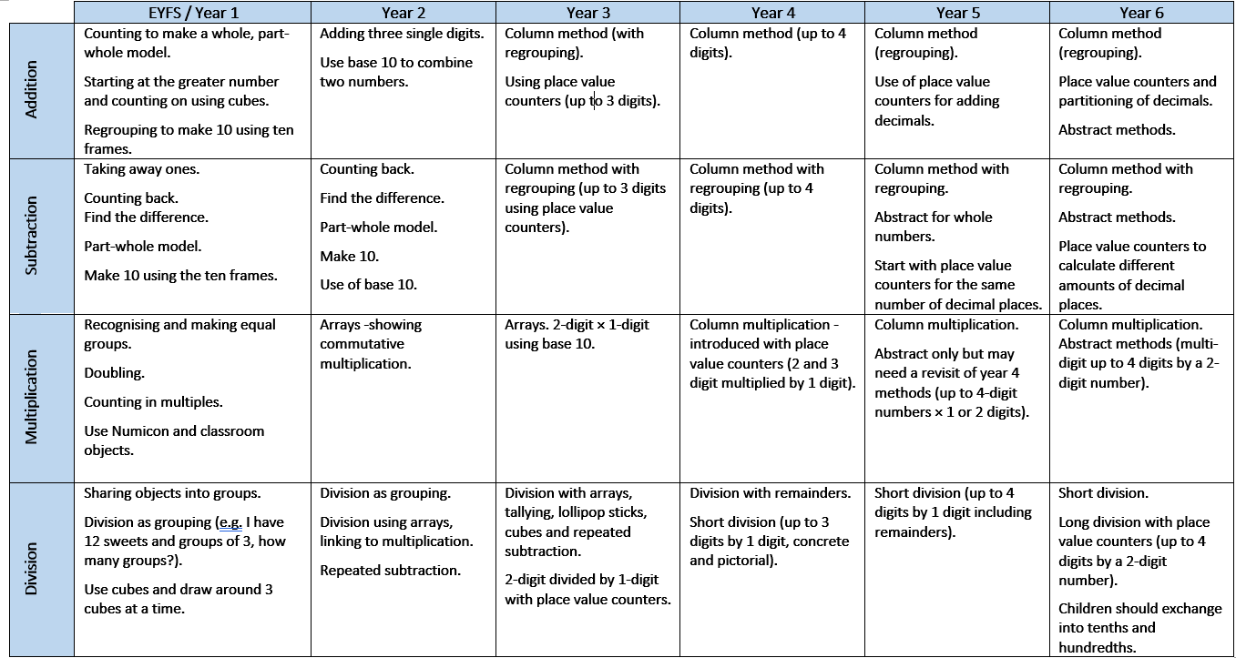
At Ludworth Primary School, we follow the White Rose Maths calculation policy as a framework for teaching and learning, adapting methods where appropriate to meet the needs of our pupils. Through a mastery approach, children are taught using a combination of concrete, pictorial and abstract representations, alongside conceptual variation, to deepen understanding and promote flexible mathematical thinking. This enables pupils to make connections, reason mathematically and become confident, fluent mathematicians.

