

Ludworth Primary School
SEND Provision

Our Commitment to Inclusion and SEND Support
At Ludworth Primary School, we believe that every child has the right to an education that enables them to flourish. We are committed to creating an inclusive environment where all pupils feel valued, respected, and supported, and where every child is encouraged to reach their full potential. We believe that having Special Educational Needs or Disabilities (SEND) should never be a barrier to learning or to accessing a rich, purposeful and balanced curriculum.
We work closely with a range of professionals and external agencies to support a wide range of children’s needs and this collaborative approach ensures each child’s needs are met in the most effective way possible. We ensure our staff receive any specific training required to meet a wide range of needs safely and effectively.
If you would like to talk more about your child’s individual SEND requirements, please get in touch with us to arrange a meeting. We are here to listen, support, and work in partnership with you every step of the way.

Supporting a wide range of SEND needs

At Ludworth Primary School, we are experienced in supporting children with a broad spectrum of Special Educational Needs and Disabilities (SEND). Our inclusive approach ensures every child receives the support they need to thrive.
We provide tailored support across the four main areas of SEND: 1. Communication and Interaction
We support children with:
- Speech, Language and Communication Needs
- Autism Spectrum Condition
2. Cognition and Learning
Our provision includes support for:
- Moderate Learning Difficulties
- Specific Learning Difficulties such as dyslexia or dyscalculia
3. Social, Emotional and Mental Health (SEMH)
We help children manage and overcome:
- Emotional and mental health challenges
- Social and behavioural needs
This includes any pupils who may have an emotional, social or mental health need that is impacting on their ability to learn
4. Sensory and/or Physical Needs
We make adjustments and offer support for children with:
- Sensory processing difficulties
- Attention Deficit Disorder
- Attention Deficit Hyperactivity Disorder
- Fine and gross motor skill challenges
- Hearing or visual impairments
- Medical conditions
- Physical disabilities

We are committed to understanding each child’s individual needs and providing the right environment, strategies, and resources to help them succeed.
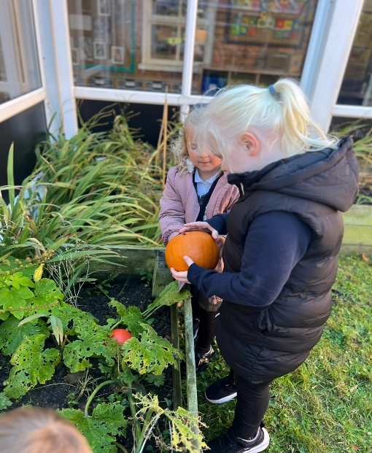

Preparing for Adulthood Introduction
Preparing for adulthood is a crucial part of supporting children with Special Educational Needs (SEN). Although adulthood may seem a long way off when your child is in primary school, early planning can make a significant difference.
Why Start Early?
Starting early helps children develop important life skills gradually, ensuring they have the best chance to become as independent as possible. For children with SEND, this early focus is even more critical, as it allows for tailored support over time.
Key Areas of Preparing for Adulthood:
Education and Employment
- Encouraging a love for learning
- Identifying your child’s strengths and interests
- Exploring hobbies and skills that could lead to future opportunities
Independent Living
- Building self-care skills (dressing, personal hygiene, making simple choices)
- Developing basic household skills (tidying, simple cooking, managing belongings)
Community Participation
- Helping your child build friendships and social skills
- Participating in community activities or groups
Health and Wellbeing
- Understanding and expressing feelings
- Encouraging healthy habits (diet, exercise, sleep)
- Regular medical check-ups and understanding any health needs

What does SEND Provision look like at Ludworth?

There are four broad areas of special educational need, these are:
- Communication and Interaction
- Cognition and Learning
- Social, Emotional and Mental Health Difficulties
- Sensory and/or Physical Difficulties
At Ludworth Primary School, we are committed to ensuring that every child thrives and achieves their full potential. Our Special Educational Needs and Disabilities (SEND) provision is designed to meet the unique needs of each learner through a personalised and inclusive approach.
Individualised Support
We recognise that every child is different. Where additional needs are identified, we work closely with families and professionals to create tailored plans that address each child’s specific requirements. This ensures that support is meaningful and effective.
Adapted Curriculum
When necessary, we adapt the curriculum to make learning accessible and engaging for all pupils. This may include breaking tasks into manageable steps, using alternative resources, or providing additional time and support so that every child can participate fully.
Adaptive Teaching Strategies
Our teachers use a range of evidence-based strategies to support diverse learning needs. This includes differentiated instruction, visual aids, multi-sensory approaches, and technology-assisted learning to help children succeed in the classroom.
Professional Recommendations
We value the expertise of external specialists and our staff are committed to working collaboratively with them. Recommendations from educational psychologists, speech and language therapists, occupational therapists, and other professionals are implemented promptly and effectively to enhance provision in school and promote positive outcomes.
Inclusive Ethos
Above all, we foster an environment where every child feels valued, supported, and included. Our goal is to empower pupils with SEND to develop confidence, independence, and a love of learning. Inclusion is not giving each child the same thing, it is giving each child what they need to succeed.
Staff at Ludworth primary are committed to ensuring that SEN provision is:
• Individualised: Tailored support plans where necessary to identify a child's specific needs
• Multi-sensory: Lessons use visuals, sounds, movement, and tactile resources
• Communication-friendly: We use tools like PECS, communication boards and visual timetables to support our learners
• Therapeutic: Staff embed calming strategies, implement sensory breaks, incorporate movement breaks and emotional regulation support
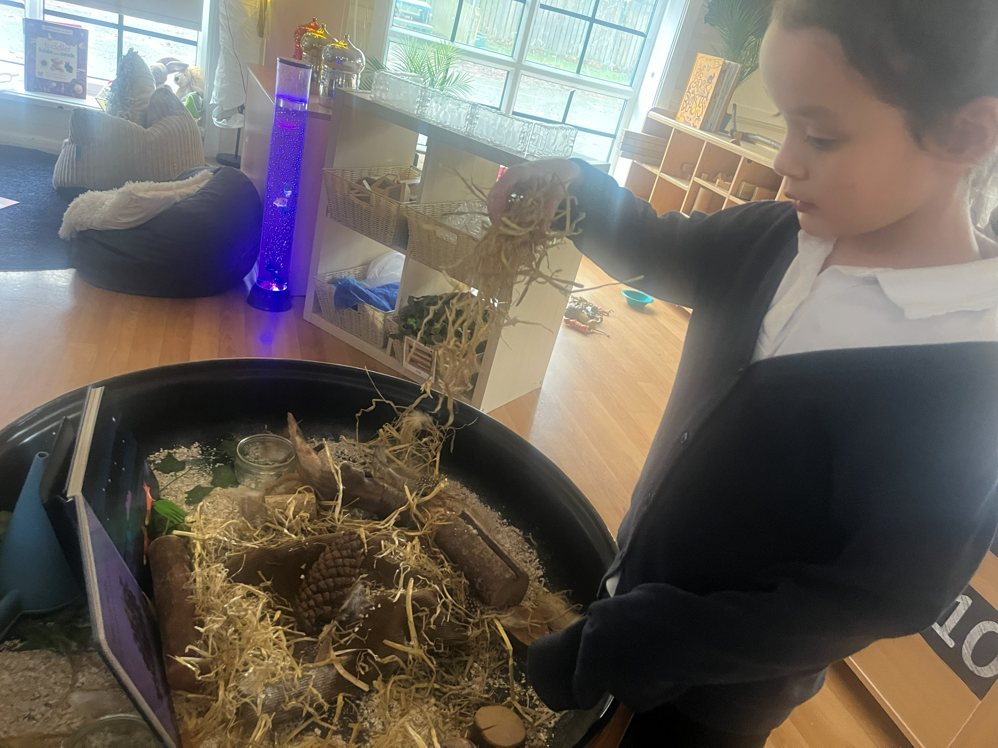

The Hub Provision
At Ludworth Primary School, we are proud of our inclusive
approach and our commitment to meeting the needs of every learner,
whatever their level of need. We adapt both the curriculum and the
learning environment to ensure pupils with SEND can access learning in a
way that works best for them.
All children are supported to follow the National Curriculum or Early Years
Foundation Stage (EYFS) Framework at a level and pace that reflects
individual strengths and needs. Where appropriate, we make thoughtful
adjustments to the classroom environment and/or curriculum to ensure it remains meaningful, engaging, and achievable.

Some children may benefit from a more personalised pathway. For these
pupils, we offer tailored support through our specialist provision in The Hub.
The Hub is a warm, welcoming and engaging classroom space designed to support children with specific needs, including those with an Education, Health and Care Plan (EHCP). It provides a calm and nurturing environment where pupils can access a curriculum that is developmentally appropriate and tailored to their individual learning goals. Within The Hub, children benefit from smaller group teaching, personalised resources, and structured routines that promote confidence and independence. Our dedicated staff work closely with families and professionals to ensure that every child receives the right support to thrive both academically and emotionally.
At Ludworth Primary School, we are committed to providing a supportive and inspiring environment for every child. If you have any questions or want to discuss your child’s needs further, please feel free to reach out to our SENCO – Mrs Robinson.

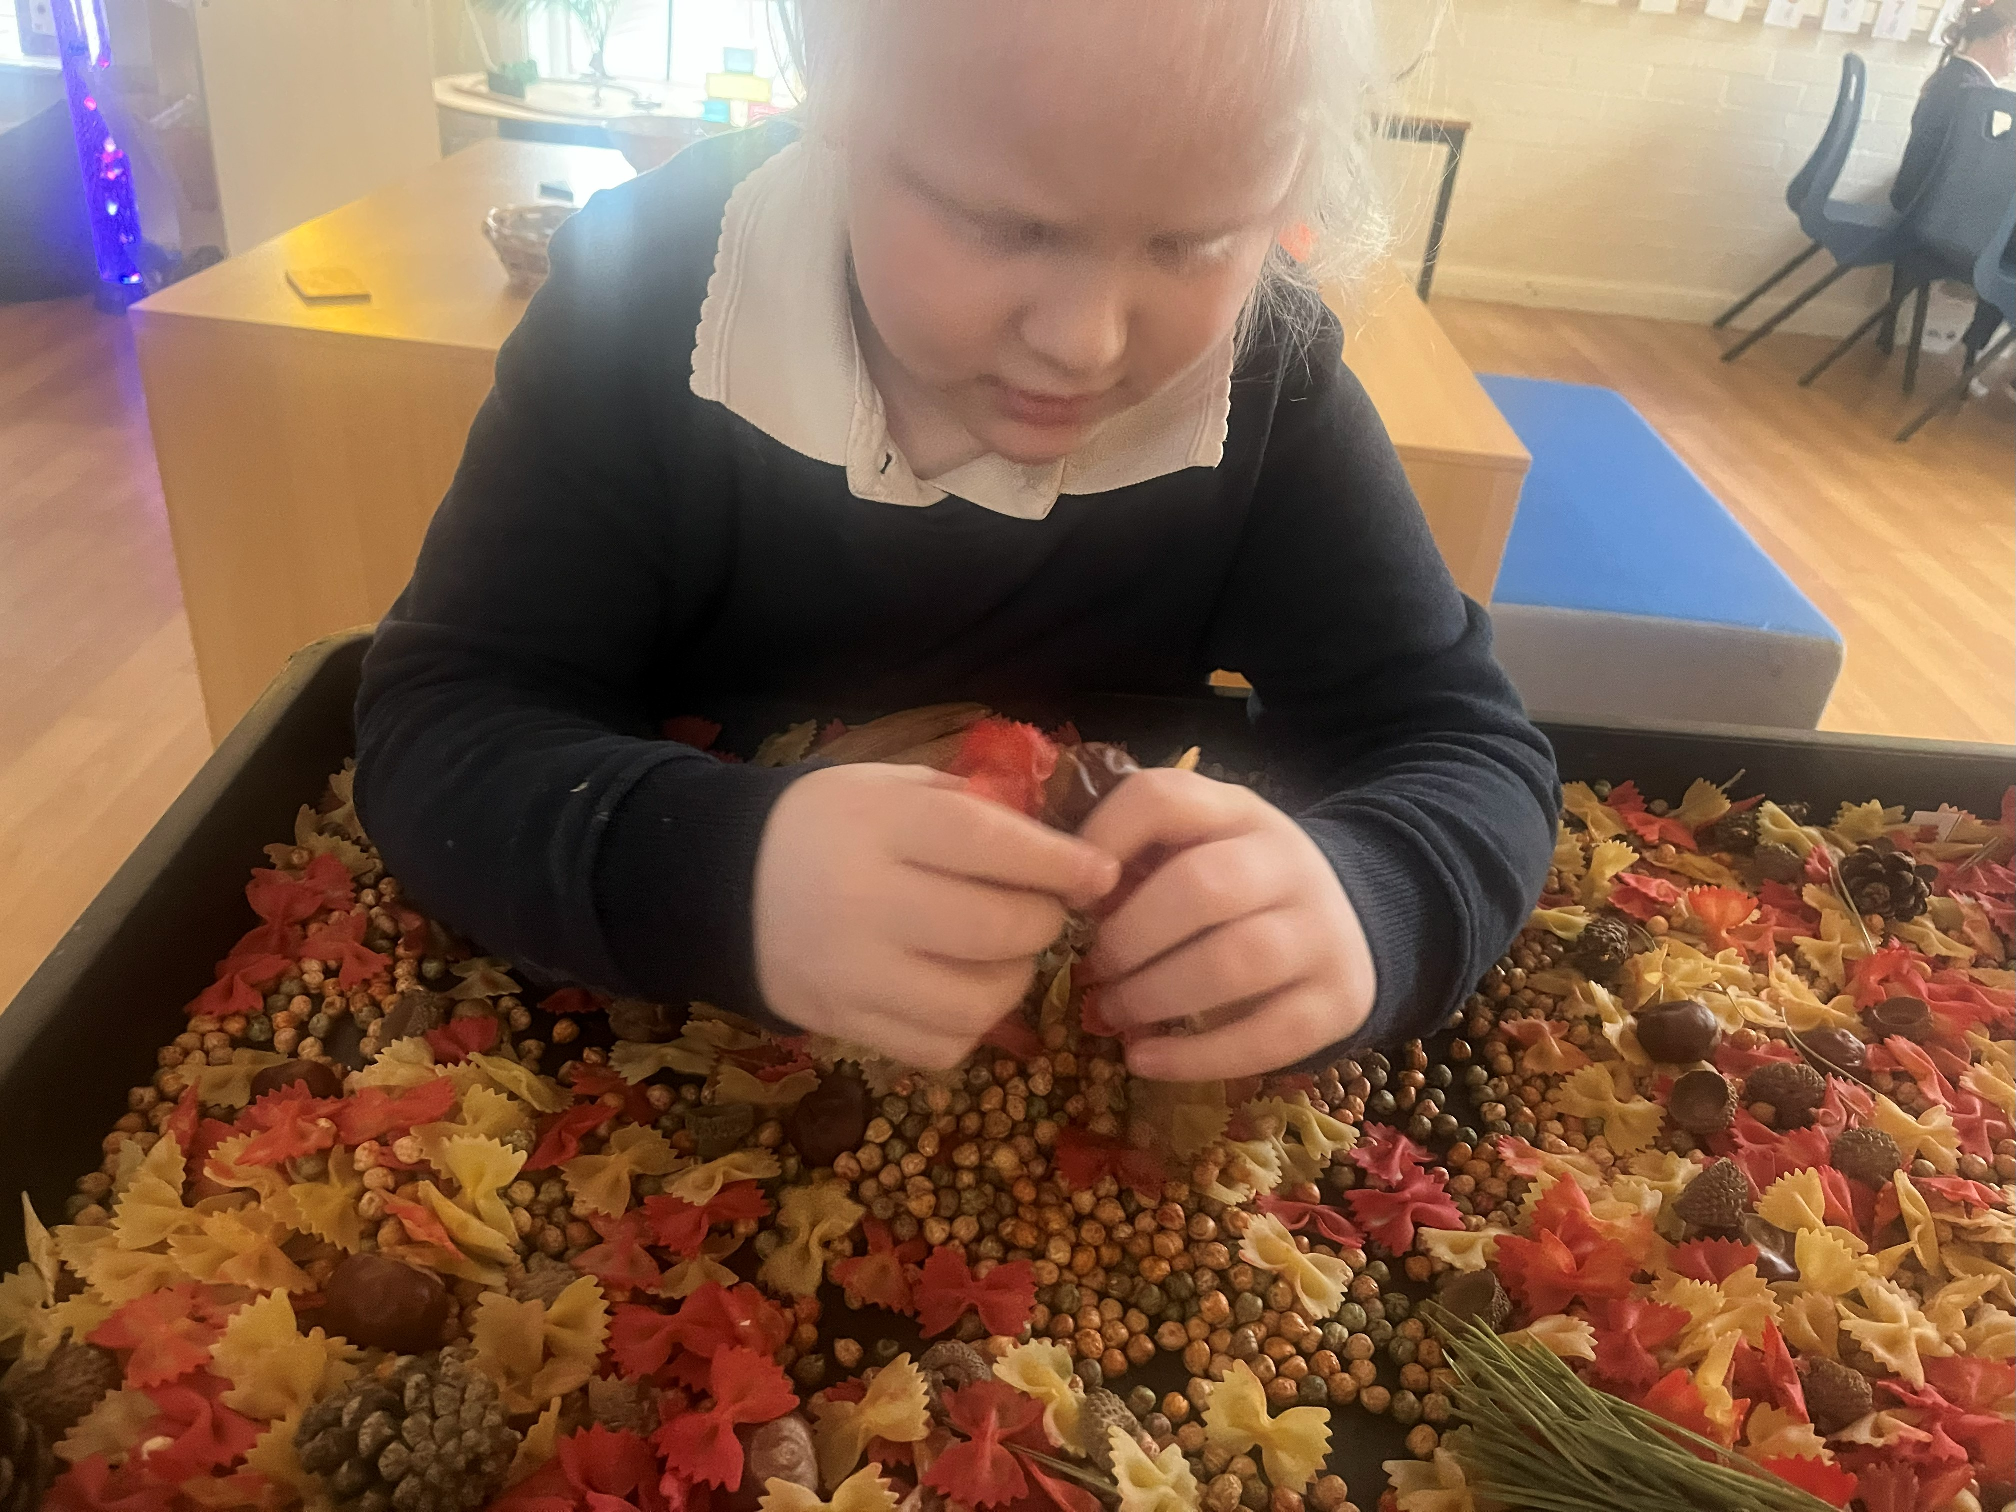

How are children identified?
The Hub is a calm, supportive space designed to help children thrive when they need a little extra time or a different approach to learning. Some children benefit from The Hub because a busy classroom can feel overwhelming, or they may need more time to build confidence in new social situations and routines. Some children may benefit from learning through a more practical, play-based and hands-on approach, which can be offered to them freely within The Hub, including more space to move and explore sensory needs. In The Hub, we focus on creating a nurturing environment where every child feels safe and ready to learn at their own pace.
Children are identified for Hub support based on their individual needs, as observed in the classroom and through input from our experienced staff and external professionals. We work in close partnership with parents and carers to ensure that any decision to access The Hub is collaborative and in the best interests of the child. Once agreed, your child will join a bespoke learning environment tailored to their developmental stage, helping them to grow academically, socially, and emotionally.
Places within The Hub vary and will always depend on the needs of the child. Some children may access The Hub provision on a morning, whilst others may access the provision whole time for a full term before their needs are reviewed. We are committed to providing a space where children are celebrated for who they are and staff will support them to fulfil their potential.
Our Curriculum in The Hub
We offer a highly personalised and carefully adapted curriculum designed to meet each child's individual needs and interests. Rooted in the Early Years Foundation Stage (EYFS) framework, our approach ensures that every child receives the right support to thrive and progress at their own pace. Our curriculum goes beyond the EYFS by incorporating a range of specialist approaches and therapies, including: Intensive Interaction, Attention Autism, Occupational Therapy input and SALT targets. These approaches are woven into each child’s daily experience to promote communication, engagement, and sensory regulation. We use a rotational timetable model that keeps children engaged and motivated throughout the day. This includes: Movement breaks, sensory circuits, individual work tasks. This flexible approach supports children's emotional regulation and allows learning to happen in a way that feels safe and manageable. Our experienced and nurturing staff ensure that each child works towards their individualised targets. Regular observations and reviews help us adapt learning plans to keep children progressing in a way that suits them best.

